**DESIGN AND IMPLEMENTATION OF A DIGITALIZED INCOME AND EXPENSE MANAGEMENT SYSTEM FOR AN ORGANIZATION**

**BY**

**POPOOLA ROFIH ABIOLA**

**NDCOM/19/389**

**A PROJECT SUBMITTED TO THE DEPARTMENT OF COMPUTER SCIENCE, FEDERAL COLLEGE OF ANIMAL HEALTH AND PRODUCTION TECHNOLOGY, MOOR PLANTATION, IBADAN.**

**IN PARTIAL FULFILMENT OF THE REQUIREMENTS FOR THE AWARD OF NATIONAL DIPLOMA**

**DECEMBER 2021**

**CERTIFICATION**

This is to certify that POPOOLA ROFIH ABIOLA with matriculation number NDCOM/19/389 carried out this project at the department of **COMPUTER SCIENCE**, **FEDERAL COLLEGE OF ANIMAL HEALTH AND PRODUCTION TECHNOLOGY, IBADAN**, under my supervision in partial fulfillment of the requirement for the award of **NATIONAL DIPLOMA** **IN** **COMPUTER SCIENCE**.

**Signature & Date**

**Mr Ayobioloja S.P**

**DEDICATION**

This project is Dedicated To God Almighty For His Infinite Grace, Mercy And Sound Health For He Made It Possible For Me To Carry Out this Project. I Also Dedicate This To My Parents, Mr And Mrs Popoola For Their Support And Motivation.

**ACKNOWLEDGMENT**

I want to acknowledge the very important fact that success in the accomplishment of this work came through the effort and assistance offered to me by many individuals to whom I owe my sincere gratitude for their various contribution to see me through this project.

My acknowledgment would be incomplete if I fail to acknowledge my prestigious supervisor in person of Mr Ayobioloja S.P, for his guidance and support towards the completion of my project, Thank you very much sir.

**ABSTRACT**

Income and Expense management has to do with monitoring of financial records of an organization. This research developed a Digitalized Income and Expense management system, that aims at turning financial records into digital format. This was developed using Hypertext Markup Language (HTML), Cascading Style Sheet (CSS) and JavaSript, and the software packages used for the development of this system are Microsoft Visual studio code, XAMPP, MYSQL, PHPMYADMIN, PHP scripting and Apache Server. With this Digitalized Income and Expense management system, keeping financial records will become more easy to record, easy to analysis, easy to access and eradicate fraudulent activities in an Organization.

**TABLE OF CONTENTS**

**Title page………………………………………………………………………………………i**

**Certification………………………………………………………………………………........ii**

**Dedication……………………………………………………………………………………...iii**

**Acknowledgement……………………………………………………………………………..iv**

**Table of content………………………………………………………………………………..v**

**CHAPTER ONE**

**INTRODUCTION**

* 1. Background of Study…………………………………………………………………….
  2. Statement of Problem……………………………………………………………………..
  3. Aim and Objectives………………………………………………………………………..
  4. Significant of Study………………………………………………………………………..
  5. Scope of Study…………………………………………………………………………….
  6. Definition of Terms……………………………………………………………………….

**CHAPTER TWO**

**LITRATURE REVIEW**

1. Concept of Expenditure Record Management………………………………………………

**2.1** Transaction Processing System (TPS)………………………………………………………

**2.2** Advantages of Income and Expense Management …………………………………...............

**2.3** Features of Digitalized Income and Expense Management……………………………………

**CHAPTER THREE**

**METHODOLOGY**

**3.0** System Investigation…………………………………………………………………………..

**3.1** Existing System……………………………………………………………………………….

**3.2** Problem of existing system……………………………………………………………………

**3.3** Proposed System………………………………………………………………………………

**3.4** APPROACH OF SYSTEM DESIGN………………………………………………………..

**3.4.1** Planning……………………………………………………………………………………..

**3.4.2** Feasibility Analysis………………………………………………………………………….

**3.4.3** System Design……………………………………………………………………………….

**3.4.4** Development………………………………………………………………………………...

**3.4.5** System Testing………………………………………………………………………………

**3.4.6** System Implementation…………………………………………………………………….

**3.5 HARDWARE AND SOFTWARE REQUIREMNET**………………………………………...

**3.5.1** Hardware used……………………………………………………………………………….

**3.5.2** Software used………………………………………………………………………………...

**3.6** Program Pseudo code…………………………………………………………………………..

**3.7** Program Flow Chart…………………………………………………………………………….

**3.8** Program Codes…………………………………………………………………………………

**CHAPTER FOUR**

**SYSTEM IMPLENTATION**

**4.1** Description of the New System………………………………………………………………...

**4.2** Recommended Requirement……………………………………………………………………

**4.3** Landing Page……………………………………………………………………………………..

**4.4** Sign Up/Sign In Page………………………………………………………………………..

**4.5** Input Page……………………………………………………………………………………

**4.6** Functionality Page……………………………………………………………………………

**4.7** Admin Login…………………………………………………………………………………

**4.8** Dashboard Page……………………………………………………………………………….

**CHAPTER FIVE**

**5.1** Summary………………………………………………………………………………………

**5.2** Conclusion……………………………………………………………………………………..

**5.3** Recommendation………………………………………………………………………………..

**REFRENCES**

**APPENDIX**

**LIST OF FIGURES**

**CHARPTER ONE**

1. **INTRODUCTION**

In modern conditions, the processes of converting information into digital form have created new approaches to the use of digital resources in the management and accounting environments of the organization’s business. To a greater extent, the transformations are caused by the processes of simplifying access to incoming data and the need to process large data volumes (in comparison with “standard” scenarios) in the work of financial services and in the accounting work of Accounts Departments - *Ziky, G. (2019). Digital Revenue and Cost Governance: Practice of Market Leaders.*

In this project we propose a web application known as “Digitalized Income and Expense Management System” which is helpful to manage organization’s income and expense whether daily or periodically. It also acts as an indicator or reminder, example in the fastest world which we are not able to remember what are the payments an organization have month for a particular month or what payment it has received for the particular month. This system will help organization to take note of all the transactions it has made throughout the month. For example, like how much expenses it has made for a particular month and what are the expenses for a year. Some of the expenditure features like total income, income made from sails, staff expenses, billing expenses like buying stationaries, electricity, taxation and some other business expenses and incomes. In this fast-moving world this web application will be very useful for organizations which has a very large amount of expenditures. Budgeting is an integral part of the society. Expenditure Tracking involves recording and analyzing the incomes and expenses of an organization over a particular period of time. Today, since we are living in a hurry up and get it done society, many people are looking forward to efficient ways to record their money inflow and outflow. During recent years, some research has been carried out on some organization, It has been noted that in most cases, income and expense management is being done non digitally(using ledgers, cash books e.t.c) being put on paper which makes expenditure tracking very difficult *- P. Thanapal (Indian Journal of Science and Technology, Vol 8(S2), 118–122, January 2015).*

**1.2** **PROBLEM STATEMENT**

Research shows that the existing system of some organization’s income and expense management system are not digitalized, This makes the system not secured and also gives room for fraudulent activities. In order to improve the existing system, There is a need to digitalize the existing system in order to have a standard income and expense management system. This system will give room for more security, easy accessibility and easy analysis.

**1.3 AIM AND OBJECTIVES**

**AIM**

To Digitalize Expense And Income Records Of An Organization.

**OBJECTIVES**

The objectives are:

* To Animate The Web Page.
* To Validate The Sign-up/Sign-in Page.
* To Develop A Calculator And A Currency Converter.
* To Design A Chart Analysis Of The Organization’s Expenditure.
* To Design A Dashboard And Database Where The Organization Can View It’s Expenditure History.

**1.4 SIGNIFICANCE OF STUDY**

The significance of this study is to eradicate a non-digitalized income and expense management system. Organizations like Schools, Hospital, Shopping Malls, Hotels, Government Institutes and many more are going to benefit a lot from this proposed solution as it will help to get their expenditure record and analysis more easily.

**1.5 SCOPE OF STUDY**

Users roles are not predefined in this system. However, it could easily be customized for usage in other organization and individual. The research work is restricted to use within Federal College Of Animal Health & Production Technology and does not extend any its features or functionality to any user apart from the department of accounting and other financial department in Federal College Of Animal Health & Production Technology. This research work is only for information collection, information storing, information analysis and users are connected to the system via the internet.

* 1. **DEFINITION OF TERMS**

**Digitalization:** is the act of converting a non-digital format into a digital format.

**Income and Expense Tracker:** is a system that helps keep an accurate record of the money inflow and outflow of an organization (Indian Journal of Science and Technology 8.S2 2015).

**Organization:** An organization is a group of people who work together to achieve a particular goal.

**Database:** A database is an organized collection of structure information, or data, typically stored electronically in a computer system.

**Dashboard:** A dashboard is a virtual display of all your data from a database.

**Structured Query Language (SQL):** is a server-side language used to connect and query the database used along with other programming languages.

**Hypertext Processor (PHP):** is a server-side scripting language used in building dynamic content for the web.

**Interface:** The point of connection between a user and the computer.

**Analysis:** Is the process of breaking down a something into its parts to learn what they do and how they relate to one another.

**JavaScript:** JavaScript is a text-based programming language used both on the client-side and the server-side that allows you to make web pages interactive.

**Hypertext Markup Language (HTML):** is a **markup** language for describing web documents (web pages).

**CSS:** itstands for **C**ascading **S**tyle **S**heets, CSS describes how HTML elements are to be displayed on screen, paper, or in other media.

**Xampp:** this is a local server, the usage is very important because it helps to tune server without touching the setting files.

**CHARPTER TWO**

**LITRATURE REVIEW**

1. **CONCEPT OF EXPENDITURE RECORD MANAGEMENT**

The evolution of computer technology has completely transformed accounting systems and studies have shown that financial outcome of an organization will always depend on how much one invests and improves the accounting information system being used (Imeokparia, 2013). In the area of accounting and finance, the use of manual financial reporting has been replaced by the use of computer soft wares to enable quick reporting and easy processing and storage of financial information. This has made facilitation of accounting soft wares, preparation and access of financial statements and use of accounting procedures easy (Kharuddin et al., 2010). In the current business world, failure to use computer software almost implies that financial information may not be accurate, there are delays in financial reporting, and that financial information may not be stored for a long time and/ or accessed when needed.

Accounting Software is a class of computer programs that perform accounting operations. It is an application software that records and processes accounting transactions within functional modules such as accounts payable, accounts receivable, payroll, and trial balance. Thus, these software packages allow the whole accounting system to be run on a computer hence the name Digitalized Income and Expense Management System (Daniel Bricklin, 1985). Every business has numerous processes; some simple, others complex and cumbersome. But as the business grows, acquires new customers, enters new markets and keeps pace with constant changes in information technology, companies need to maintain highly accurate and up-to-date accounting, inventory and statutory records. This is where a Digitalized Income and Expense Management System helps simplify, integrate, and streamline all the business processes, cost-effectively and easily and helps present the true picture of all the business undertakings to users of financial reports. With the decrease in the price of computers and accounting programs, this method of book keeping is becoming popular (Raymond and Bergeron, 1992).

A Digitalized Income and Expense Management System is an accounting information system that processes the financial transactions and events as per Generally Accepted Accounting Principles (GAAP) to produce reports as per user requirements. Every accounting system, manual or Digitalized, has two aspects. First, it has to work under a set of well-defined concepts called accounting principles. Secondly, there is a user -defined framework for maintenance of records and generation of reports.

**2.1 TRANSACTION PROCESSING SYSTEM (TPS)**

The Transaction Processing System plays a huge role in recording and processing diverse business transactions. It basically records, corrects, validates, processes, stores and displays information. The business employing it can later retrieve this information and use it for various purposes.

The TPS performs its tasks using many steps and procedures. Some of these steps are as follows:

**Entry of data:** Firstly, the user enters data into the system using input devices like keyboard, mouse, barcode scanner or interactive screen.

Validation of data: Next, the system uses a set of programs that compute and validate the data users enter in it.

**Processing of data:** Once the system validates the data and checks its accuracy, it then processes it on the basis of the user’s commands.

Storage of data: After processing data, the system stores it either in its short-term memory or the long-term one. This depends on the user’s command.

**Reporting of information:** Finally, processed data is now called information, which is displayed to the user in pre-determined formats.

The Transaction Processing System also performs real-time accounting operations. Users can edit and use this data digitally using the internet. The reports generated by the system are stored and displayed in a language called Structured Query Language.

* 1. **ADVANTAGES OF DIGITALIZED INCOME AND EXPENSE MANAGEMENT**

**1.** **Automation**

To make sure that all calculations are correct and accurate it is important to use something other than pen and paper. The systems we provide also take care of all procedures automatically so that invoices are created and manual accounting is taken care of efficiently.

**2. Data Access**

Using the software becomes easier and gives you easier access to data files when you need them. You no longer have to search through endless piles of paper and files to find a certain date, data file or piece of information as they are all there for you at the click of a button.

**3. Accuracy**

An accounting system is designed to be completely accurate right down to the final detail. Although your maths skills may be 10/10 it is always safer to use a computerized system to do the calculations for you. It also automatically does additions, subtractions and calculations once you have submitted data making the whole process quicker.

**4. Reliability**

Of course they are reliable systems to use. They are smarter than any accountant can ever be and take care of tasks when you tell it to. You can count on your computerized system to take control of your accounts when you don’t have the time to.

**5. Speed**

A computer is always going to be faster than a human being and when it comes to accounts they are faster than ever before. Statements, reports, analysis and everything you need can be created at the push of a button so you can get access to your accounts in quick time.

**6. Security**

The latest technology can be saved and stored off site so there is no threat of intrusions and stealing of data. The systems can always be restored from old data files and backups are vital to make the most of clever accounting. With password protected areas and certain accounts for different parts of the business you can control who has access to the systems for extra safety.

**7. Scalable**

No matter how large your company grows you can always count on a computerized system to grow with you. Everything is straight forward and the data systems will always store your files efficiently unlike stacks of paper would.

**8. Visuals**

It is always easier to look at your accounts and customer’s accounts on a computer rather than trying to read handwriting that is impossible to read. You can arrange them in a way that suits you and quickly view reports and data sheets in quick time.

**9. Cost Effective**

Using a computerized system is a lot cheaper than other forms of data filing due to it being overall more efficient. As the work is automatically done and all reports are kept in one area, everything is completed quicker and will save time massively. Organization also save money on various accountant’s fees, report creations, paper filing and still make sure your accounts are in perfect order.

* 1. **FEATURES OF DIGITALIZED INCOME AND EXPENSE MANAGEMENT**

**1.** It leads to quick preparation of accounts and makes available the accounting statements and records on time.

**2.** It ensures control over accounting work and records.

**3.** Errors and mistakes would be at minimum in computerized accounting.

**4.** Maintenance of uniform accounting statements and records is possible.

**5.** Easy access and reference of accounting information is possible.

**6.** Flexibility in maintaining accounts is possible.

**7.** It involves less clerical work and is very neat and more accurate.

**8.** It adapts to the current and future needs of the business.

**CHAPTER THREE**

**METHODOLOGY**

1. **SYSTEM INVESTIGATION**

The investigation method refers to the ways the existing system does the job of collecting income and expense records in an organization. The importance of investigation is to understand the mode of operation of the existing system and thus use it as a basis for developing the new system, rectifying the flaws and lapses of the existing system. An interview was conducted with an accountant from in organization, to know how the existing system is been done in terms income and expense recording.

The purpose of this interview was to know how the existing system works based on the following findings:

1. The method used to collect income and expense records in an organization.
2. The efficiency and simplicity of the existing system.
3. The approach used to manage the information recorded.
   1. **EXISTING SYSTEM**

The Existing system used in income and expense management by Federal College Of Animal Health And Production Technology wants to balance the income and expense for each month they have to do it manually but they can’t do this for each and every month those who have a lot of income and expenses, so to reduce the stress for the organization and make it easy to calculate the income and expense, this system has been so much helpful for an organization to avoid the manual way of calculating the income and expense**.**

* 1. **PROBLEMS OF THE EXISTING SYSTEM**

The existing system has the following flaws:

1. Lacks Security
2. Complexity
3. Cost Intensive
4. Time consuming
5. Non-User friendly
6. It is not automated and Lacks accuracy
7. It is not reliable

**3.3 PROPOSED SYSTEM**

In view of the problems of the existing system, here are the proposed solution:

1. Introducing the use of passwords to grant accessibility.
2. Implementing a simple and user friendly interface for greater User Experience.
3. Strict authentication of user login credentials.
4. Automating the system to calculate every expenditure recorded.
5. A software with low system requirement and high efficiency.
   1. **APPROACH OF THE SYSTEM DESIGN**

**3.4.1 *Planning*:** This is the initial stage of the project where the project goals are determined and high-level plan for this project was establish. At this stage resources needed were determined and feasibility report was carried out to determine the condition of the environment where the project will function.

**3.4.2 *Feasibility Analysis:*** At this stage the project was defined in details and the possibility of this project becoming a reality was checked. Therefore, workflow was divided into small tasks so that the process of development, testing, design and project management can be evaluated. At this stage the project’s feasibility was checked in terms of cost, time, functionality and reliability.

**3.4.3 *Software Design:*** This stage requires the use of prototyping tools in order for the project to be a product of creativity and to be affirmative. This process involved overall product design along with data structure and database design.

**3.4.4 *Development****:* The purpose of this stage is to convert the system design prototypes into working information systems that addresses all documented system requirement. Here PHP, JavaScript. Html, CSS was used to design the system.

**3.4.5 *Implementation and Integration:*** All of the development work was executed at this stage to fit the purpose of the project. At this stage the project becomes more transparent to the prospects, to whom it may appear that the project is now a reality.

**3.4.6 *Testing:*** At this stage focus was placed on investigation and discovery. During this stage the project was checked, some errors were identified during testing such as: the input and storing of each record into the database was not submitted but at the end of the day it was corrected. And implementation was done to fit user’s requirement and also an overall quality assurance test was performed to assure the best working performance of the project.

**3.5 HARDWARE AND SOFTWARE REQUIREMENTS**

The following are the hardware and software requirement used to develop this system:

**3.5.1 Hardware used**

* Intel core 2 Duo CPU 2.10Ghz x 64bits Processor
* 6.00Gb RAM & 250Gb HDD
* 1366 x 768 32bits 60hz Generic PnP Monitor

**3.5.2 Software used**

* Windows 10/ 11 Pro
* Microsoft Visual Studio 2019
* PHP programming Language
* JavaScript Programming Language
* MySQL Database Management System
* XAMPP server

**3.6 PROGRAM PSEUDOCODE AND FLOW CHART**

**3.6.1 User Authentication System**

***Pseudo code:***

* Begin Process.
* Input Username.
* Input Email.
* Input Password.
* Sign = username, Email and Password in database.
* If (Sign = true) allow user into input page ELSE reject user access.
* End Process.

**3.6.2 Input Income and Expense System**

* Begin Process.
* Fill in all require fields.
* Check = If all required field are not empty.
* If (Check = true) print “Success” Then Save Inputs into Database.

**ELSE GO TO 2.**

**3.7 Program Flow Chart**

There are two types of flow charts discussed below and the first one explained user authentication, the second one talked about income and expense input page and the Third one talked about Admin access to dashboard.

**3.7 User Authentication System**

**Input Username, Email and password**

**Validity check: Checks if Username, Email and Password are correct**

**Validity Check**

True

False

**Print “Login Successful”**

**Print “Invalid Input”**

**Allow User Into Input Page**

**3.7.2** **Input Income and Expense System**

**Flow Chart**

**Fill in all required fields**

**Validity check: Checks if all are filled**

**Validity Check**

True

False

**Print “Invalid Input”**

**Print “Success”**

**Store inputs into database**

**3.7.3 Admin Access into database**

**Flow chart**

**Input Admin name, Admin Email and Admin password**

**Validity check: Checks if Admin Username, Admin Email and Admin Password are correct**

**Validity Check**

True

False

**Print “Login Successful”**

**Print “Invalid Input”**

**Allow Admin Into dashboard**

**3.8 PROGRAM CODES: see appendix**

**3.9 Database Design**

The Database Management System used for this design is MySQL and this was chosen because:

1. It is very easy to setup as it is compatible with almost all hosting servers.
2. It provides strong data protection.
3. It works at a very high speed.
4. It provides a unique storage engine architecture that allows configuration for specific applications.
5. It is scalable and flexible in nature.

User (Organization)

|  |  |  |
| --- | --- | --- |
| **Attributes** | **Data Type** | **No of Characters** |
| Id | Int | 11 |
| Payer’s Name | Strings | 200 |
| Description | Strings | 225 |
| Amount | Big Int | 225 |
| Time/Date | Time Stamp | 20 |

Administrator

|  |  |  |
| --- | --- | --- |
| **Attributes** | **Data Type** | **No of Characters** |
| Admin Username | String | 20 |
| Admin Email | Strings | 20 |
| Admin Password | Varchar | 220 |

**Entity Relationship Diagram**

Access

**Users**

**Database**

**CHAPTER FOUR**

**SYSTEM IMPLEMENTATION**

**4.1 DESCRIPTION OF THE NEW SYSTEM**

This system makes use of universal login system, which allows the user login from any machine (device), this system would provide a user(organization) with the opportunity to input all the transaction details include the receipt which is in form of an image into the database. The transaction details can only viewed by admin in the dashboard. In the dashboard, the admin can set a budget, view the chart analysis of each month and see the available balance of the organization. The input page also has a calculator, a currency converter, a calendar and time/date.

From the Landing page the user will be able to navigate the following:

1. Sign up/Sign in page
2. Input page
3. Calculator page
4. Currency converter page
5. Dashboard
6. Budget allocation page
7. Chart analysis page

**How Users Will Relate With This System**

In this system, users are categorized into two parts: Users and Admin.

**Admin**

The Admin will manage, analyze and monitor the transaction details which was record by the user and will also allocate budget in the dashboard.

**Users**

Users will login into the system and input all the organization’s transaction detail which will be recorded in the database/dashboard.

**4.2 RECOMMENDED REQUIREMENTS:**

**Hardware**

* Intel Core 2 Duo CPU 2.10Ghz x 64bits Processor
* 2.00Gb RAM & 20gb of storage
* 1366 x 768 32bits 60hz Generic PnP Monitor

**Software used**

* Windows 10/ 11 Pro
* Chrome Browser
* XAMPP server

**4.3.1 INPUT PAGES**

**Landing Page:** This is the page were the user will first see, the essence of this page is to introduced the user about the page.

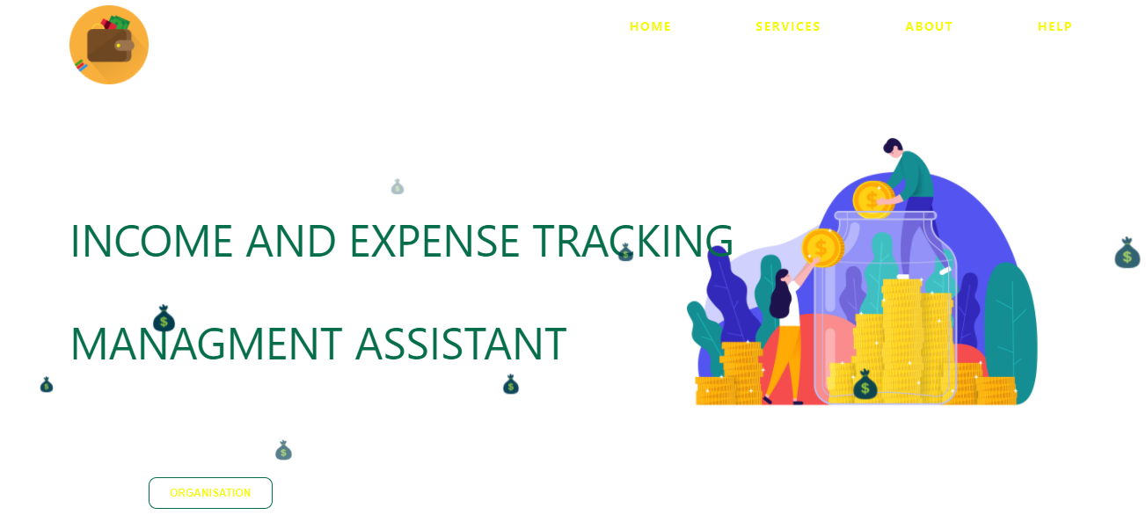

Figure 4.1 Landing Page

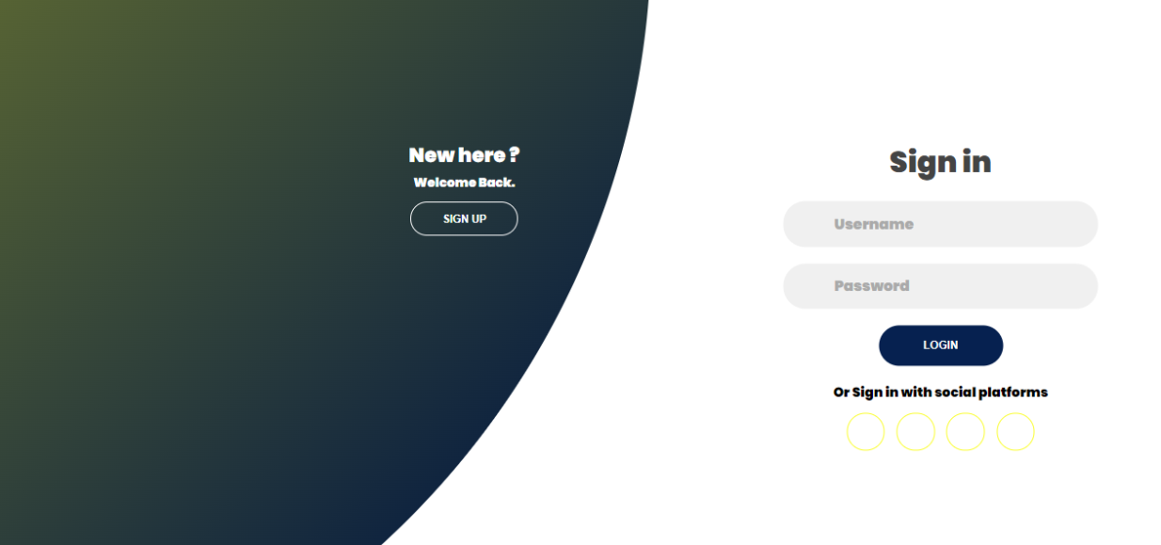**4.3.2 Sign Up/ Sign In Page:** This is the page that validates the authenticity of user’s credentials before giving access to the input Page.

Figure 4.2 Sign Up/ Sign In Page

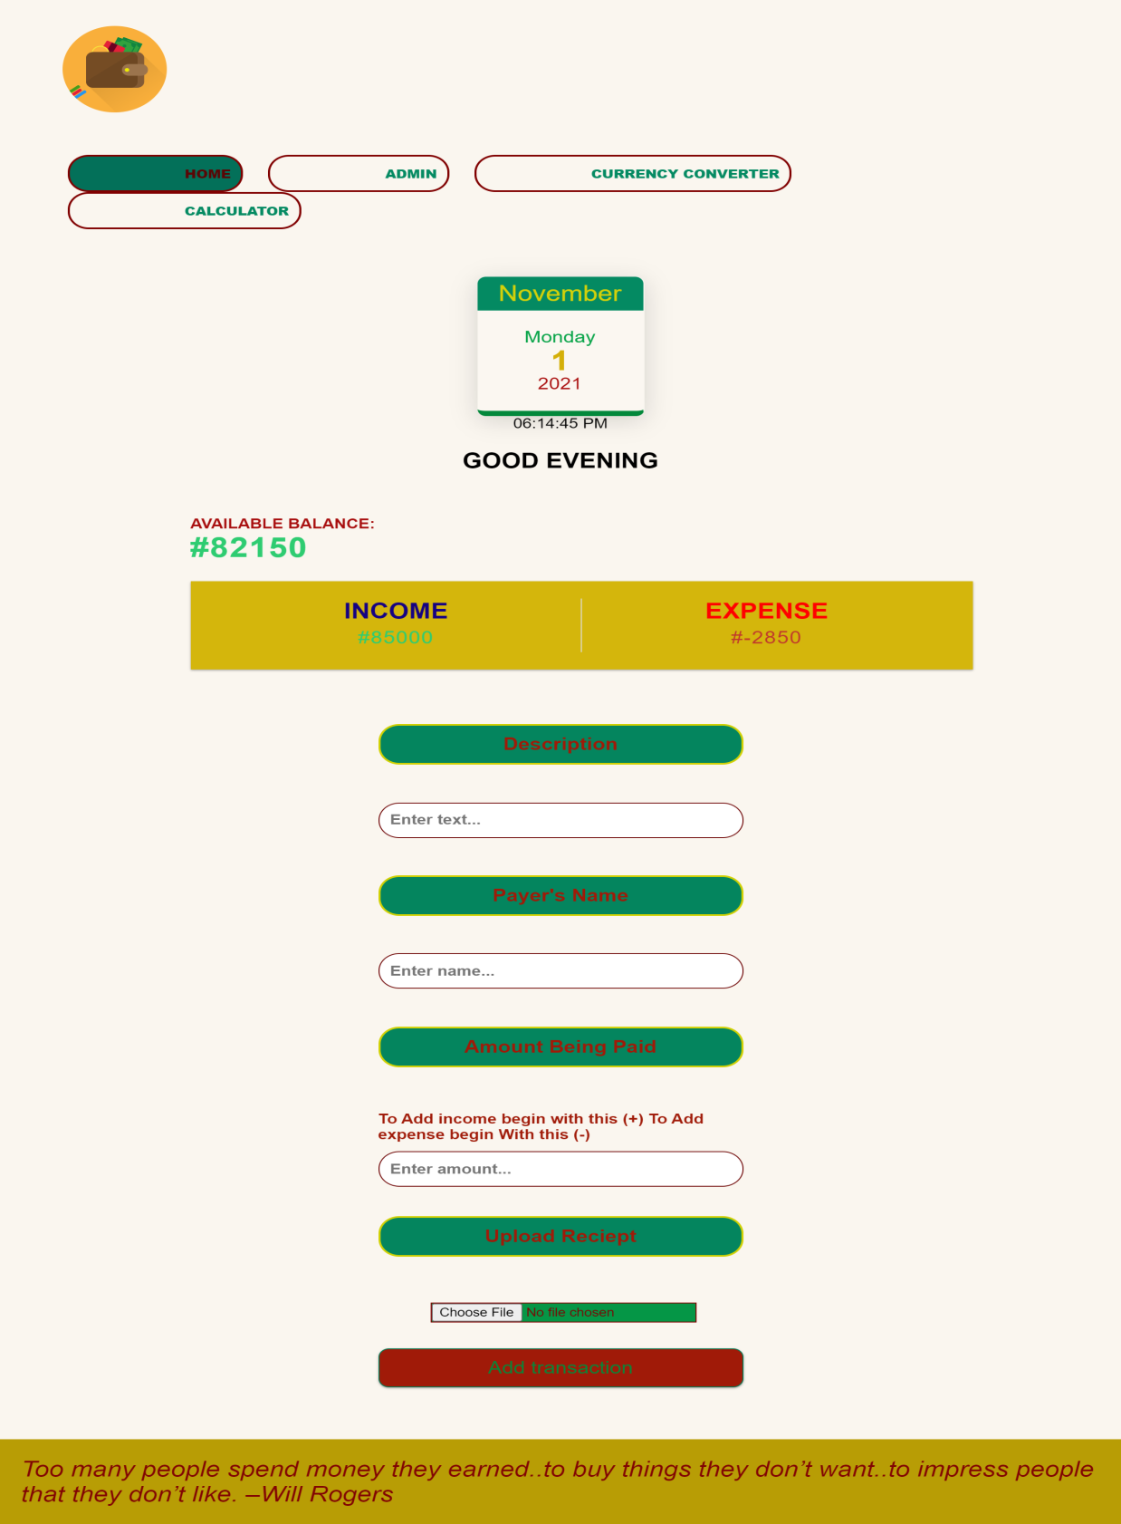**4.3.3 Input page:** This page allows the user input all the transaction details which includes: Payer’s name, Description, Amount and Receipt.

Figure 4.3 Input Page

**4.3.4 Calculator:** This page allows users perform arithmetic operations .



Figure 4.4 Calculator Page

**4.3.5 Currency Converter:** This page enables the user convert one currency to another eg Dollar to Naira. Figure 4.5 Currency Converter Page

**4.3.6 Budget Page:** This is page where the admin allocate budget for the organization.

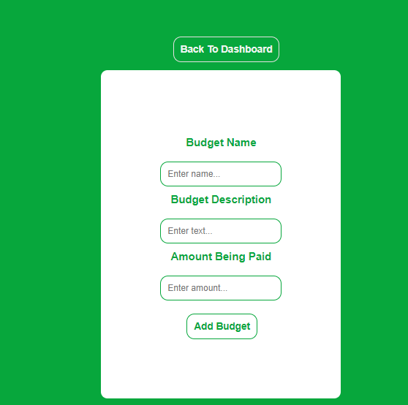

Figure 4.5 Currency Converter Page

**4.4 OUTPUT PAGE**

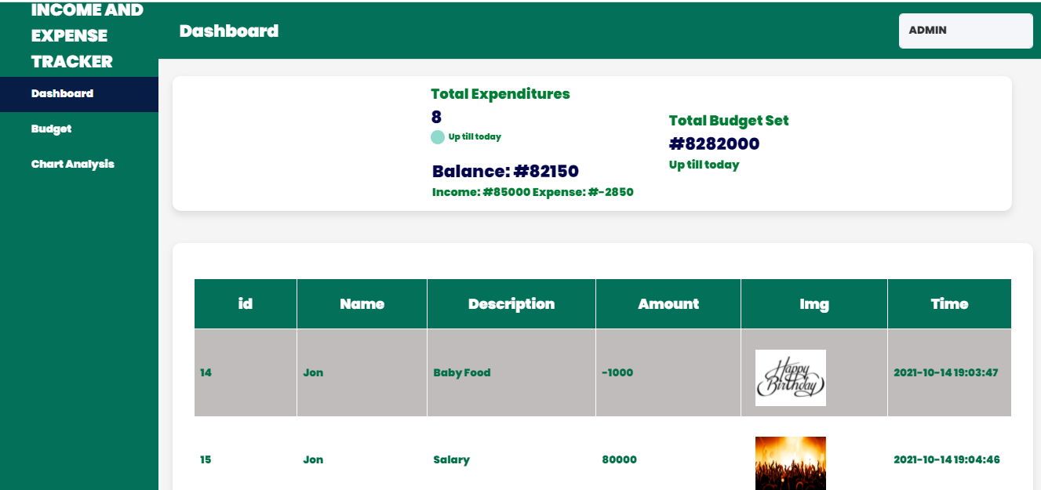**4.4.1 Admin Dashboard:** This is the page where the administration can view all the transaction details, which is recorded by user.

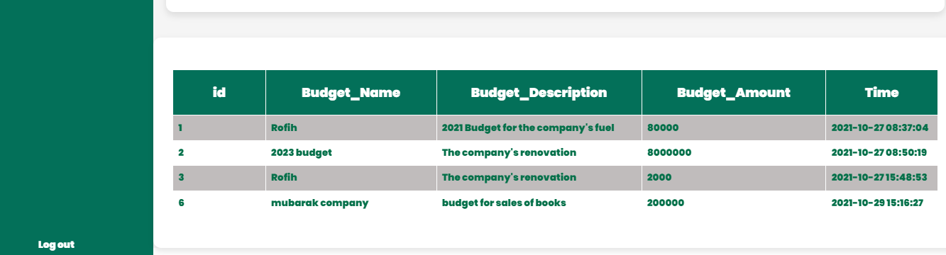

Figure 4.6 Dashboard Page

**4.5 Database Design**

This is the database for the system.

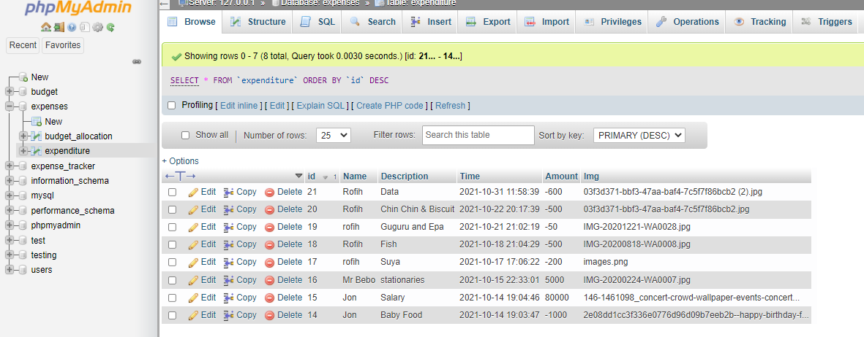 Figure 4.7 Database Page

**CHAPTER FIVE**

**SUMMARY, RECOMMENDATION AND CONCLUSION**

* 1. **SUMMARY**

The project has been developed to work more efficiently than the manual income and expense record system. The project successfully avoids the manual calculation for avoiding calculating the income and expense per month. This was developed mainly to improve and to avoid the manual way of recording organizations financial transactions.

* 1. **CONCLUSION**

The results of this study shows the importance of digitalized income and expense management system and its impact in organizations development. The pages for the website had also been designed(Landing page, Sign-up/Sign-in page, Input Page, Calculator page, Currency Converter Page, Budget Allocation Page, Dashboard), this website combines a user and the admin. The new system, will be a good initiative in promoting proper financial practice. The new system was developed using hyper-text markup language(HTML), Hypertext processor(PHP) and cascading style sheet(CSS).

**5.3 RECOMMENDATION**

Although the developed income and expense management system is currently meeting the general aim of the project and it is working fine as specified, there are still areas that needs improvement and further enhancement; these includes payroll, cash advance and a record for every staff in the organization.

**REFERENCES**

Nakyobe, J., Nambi, E., Aguti, E. & Ssewankambo, W. Regional Universities Forum for Capacity Building in Agriculture (RUFORUM) Makerere University Main Campus, P.O. Box 16811, Wandegeya, Kampala, Uganda.

P. Thanapal*, Mohammed Yaseen Patel, T.P. Lokesh Raj and J. Satheesh Kumar SITE, VIT University, Vellore, Tamil Nadu, India; thanapal.p@vit.ac.in, [yaseenpatel22@gmail.com](mailto:yaseenpatel22@gmail.com).

Varian, H. R. (2005). Copying and copyright. Journal of economic perspectives, 19(2), 121-138.

Ziky, G. (2019). Digital Revenue and Cost Governance: Practice of Market Leaders. Ernst and Young.

**APPENDIX**